Task P – Spike: Dice Rolling Game

Goals:
The goal of the assignment is to create a dice-rolling game. This game needs to include the state-handle, creating constraint layout, localization and using the Log for debugging
List of knowledge gaps:
- Constraint Layout design
- Button Event listener
- Display number and image view
- Game logic
- Save state when rotating the device
- Localisation
- Debugging with log
- IDE command
- Testing the app

This is the link to my GitHub https://github.com/SoftDevMobDev-2023-Classrooms/core1-bbi3mn4u69.git

Tools and Resources Used
- Android Studio
- Build a Responsive UI with ConstraintLayout n.d., Android Developers. <https://developer.android.com/develop/ui/views/layout/constraint-layout>
- Localize the UI with Translations Editor | Android Studio n.d., Android Developers.
< https://developer.android.com/studio/write/translations-editor>
- How to Translate Your Android App to Any Language (SO EASY!) - Android Studio Tutorial n.d., www.youtube.com, viewed 1 September 2023, <https://www.youtube.com/watch?v=LXbpsBtIIeM&t=277s>.
- ‌ Dice image < https://www.flaticon.com/search?word=dice >

Knowledge Gaps and Solutions

Gap 1: Constraint Layout
Before come to coding the app, we have to design the overall UI of the app. We can access it in the activity_main.xml
In this app, I will create 2 layouts, the first one for portrait, the second one will be the landscape layout.

Figure 1 layout path
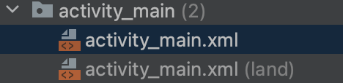
Figure 2 two layout
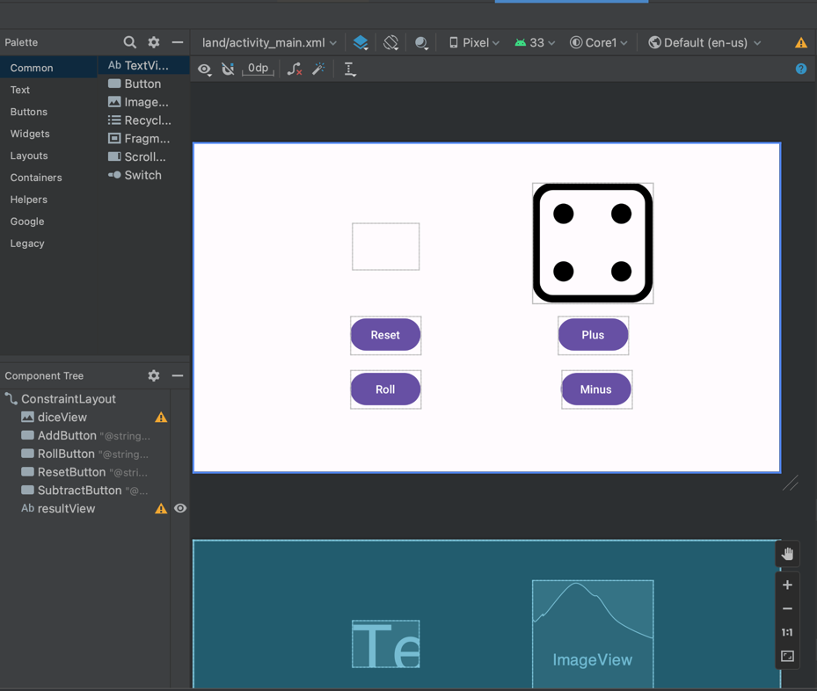
Figure 3 landscape layout design
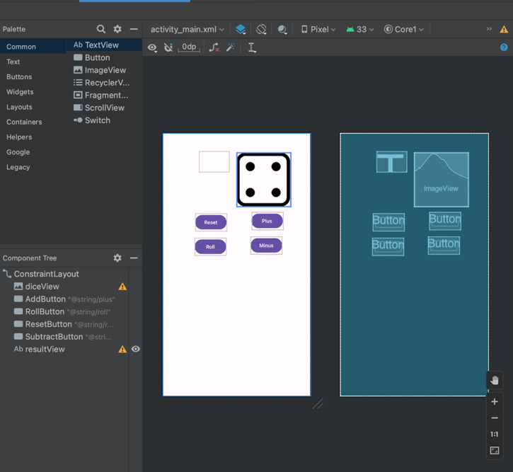
Figure 4 portrait layout design

Gap 2: Button event listener
To make the button work, the button event listener needs to be created in the MainActivity.kt
First, we need to define the button using the findViewById:

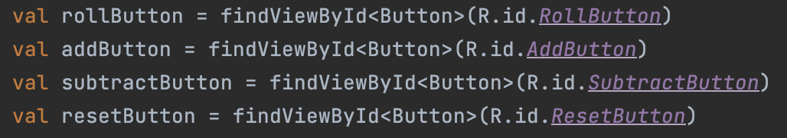
Figure 5 define the button

Each button is assigned to an immutable variable, then the setOnClickListener is implemented. When the button is pressed, some function will be performed. These functions we will revisit in the game logic later. We will do the same for the other button.

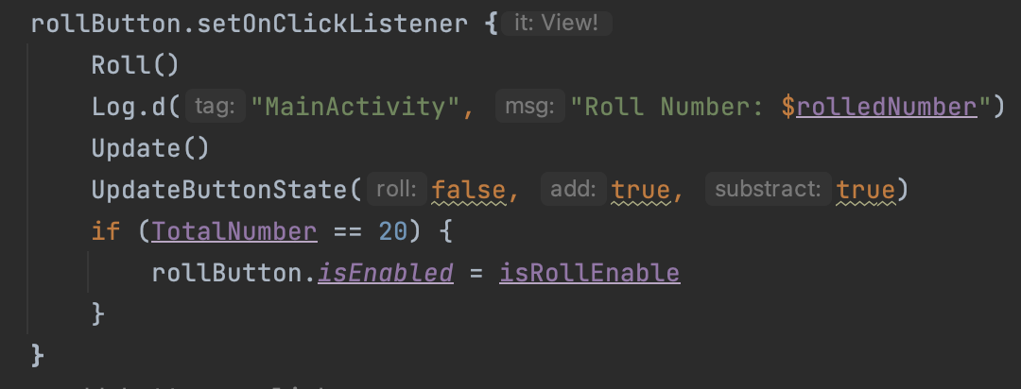
Figure 6 Button event listener

Gap 3: Display number and Image view
For the number view and image view, first, we also need to define it with the immute variable. The number view here will be used to display the score. Meanwhile, the image here is used to display the dice.

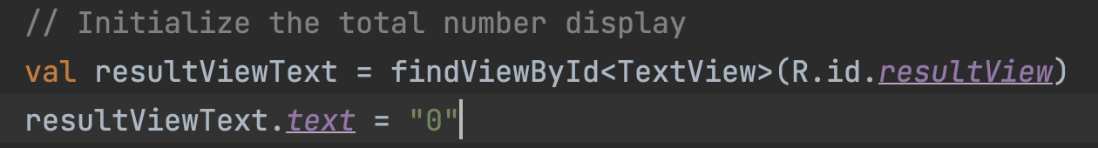
Figure 7 define number view
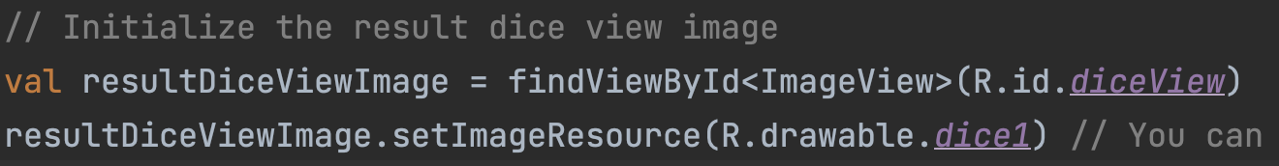
Figure 8 define image view
In here, we are using the TextView to display number. So that number are being treated as a string. To adapt, the number need to be converted to string to display it on the screen. For the image view, the image need be input in the resource file.

Gap 4: Game Logic
- the button:
Based on the requirement, there will be four buttons including add, subtract, reset and roll. As the requirement, button should be enable when they can be used. As the reset button can be pressed any time so we will not worries about the condition for the reset button to enable or disable. Initially, there will be:

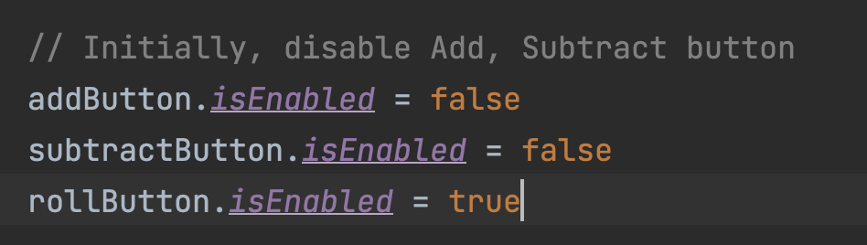
Figure 9 State of button initially
The add button will be disable, as well as the subtract button. In the very beginning of the of the game, the roll button is being enable to roll the dice.

Add button:

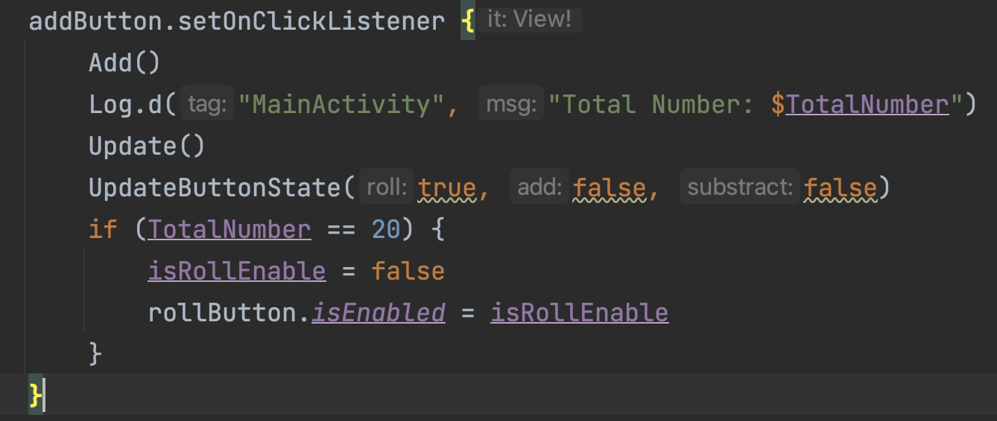
Figure 10 add button onclick
The add button when on clicked will perform the add function:

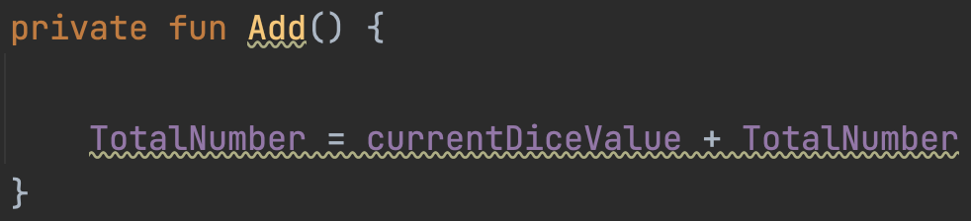
Figure 11 add function
The add function will calculate the score buy adding the current dice number being rolled with the current score. I initialize a variable called TotalNumber which represent the score.

Subtract button:
Similar to add button, the subtract button is also perform a calculation which in the subtract function:

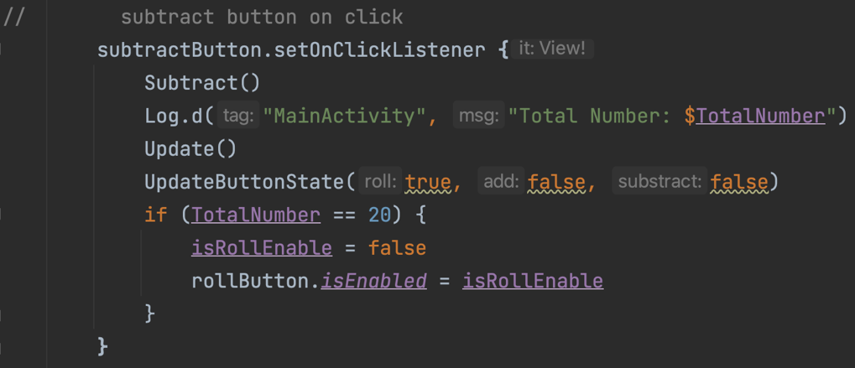
Figure 12 subtract button on click

The subtract button contains a logic which a bit different from the add button, As the requirement, the score can not be a negative number so if the TotalNumber(score) is greater than the current dice values, the subtract will happen. Meanwhile, if the TotalNumber(score) is in a negative state, the score will remain 0
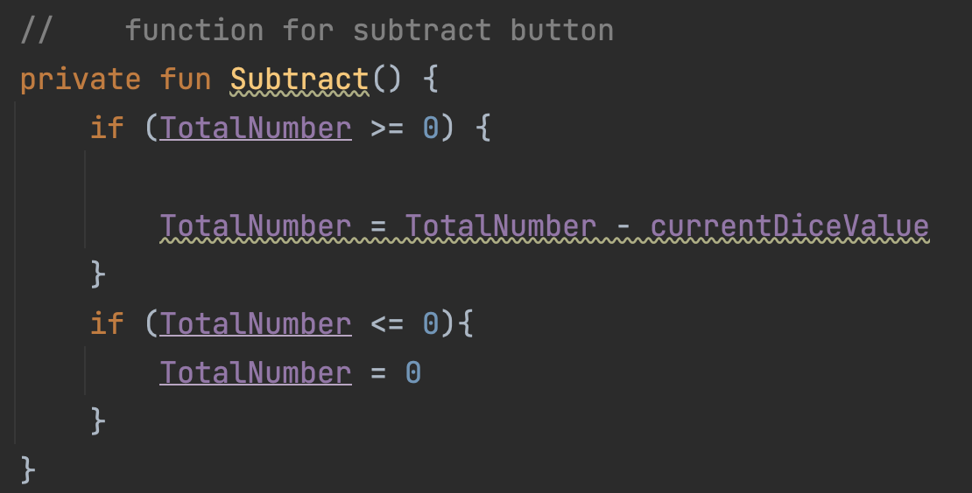
Figure 13 subtract button logic

Roll Button:

The roll button will be used to roll the dice to create a random value. But we need to check for a condtion that if the TotalNumber(score) reach 20, the roll button need to be disable:

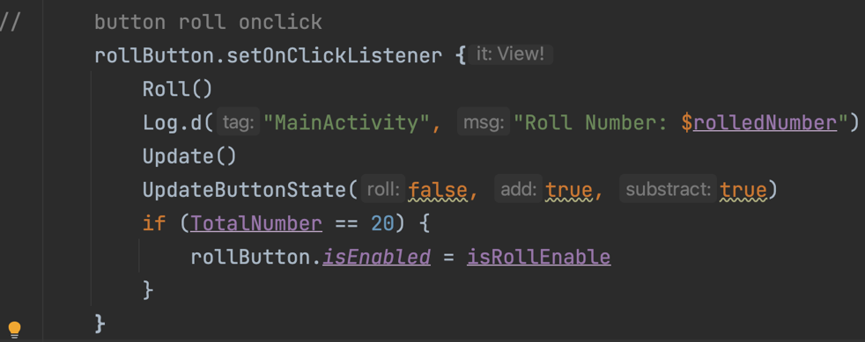
Figure 14 Roll button on click
The assignment required we using a random seed 1, the list of number being randomed will be fixed with the number in the the defined position, we will talk more about this in the random logic

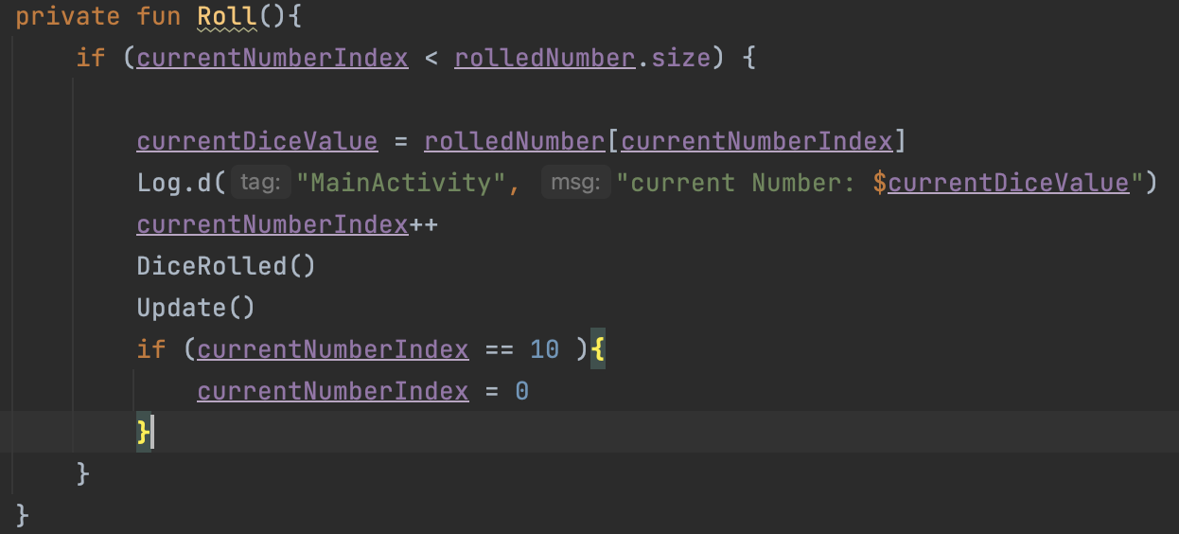
Figure 15 Roll button Logic
The roll function will access the number in rolled number list of integer, which we already have a fixed list of number. Each time we press the roll button, the current dice values will be assigned to the next number in that list if the current index reach out of 10 integer in that list, it need to be set back to the beginning of the list.

Reset button:

The reset button is used to reset the score when it reaches 20. As I mentioned earlier, the roll button will be disabled when the score reaches 20, so the reset button will need to enable the roll button. Meanwhile, it will reset the score back to 0.
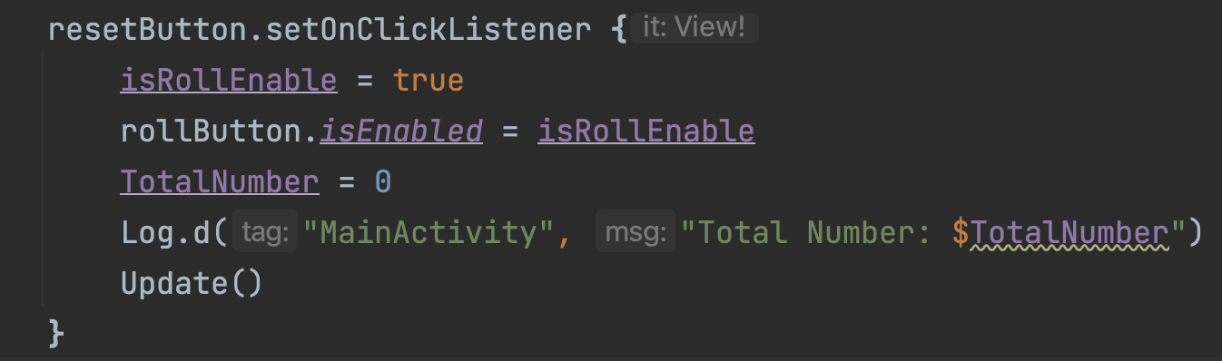
Figure 16 Reset button on click

- The Rolling Dice logic:

First, we will need a variable for the random number list being created by the function RollTheDice. The random values will use the seed of 1 which generate a list of 10 integers from 1 to 7 in a fixed random position (figure 15)

Figure 17 list of random number

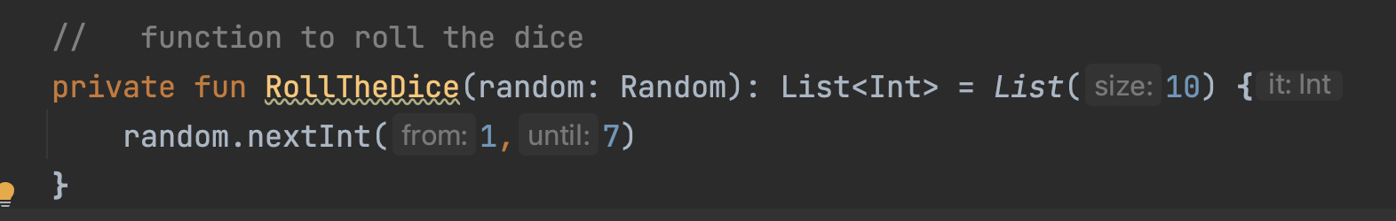
Figure 18 function to create a random number with the seed of 1

Figure 19 List of random number
If the roll button is pressed, the number will be taken from that list with the increase of the index number

Check if reach 20:

The values of TotalNumber need to be checked every time if it reaches 20. So the function named update is being created to check it every time when the button is pressed:

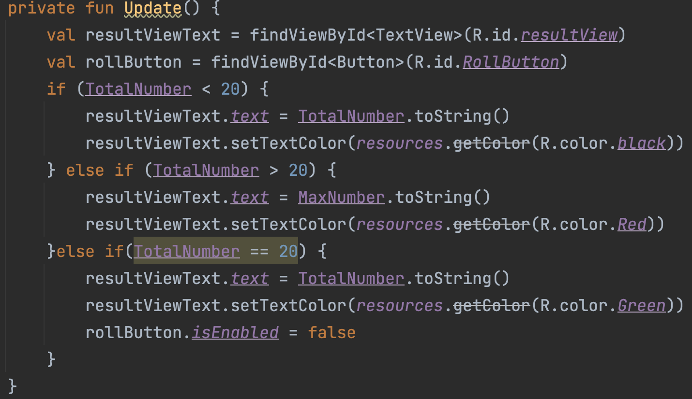
Figure 20 check if reach 20
As the requirement, the TotalNumber(score) will remain black when it is under 20. I have created a variable named MaxNumber which has the values of 20. If the score is more than 20, the MaxNumber will be displayed with the red colour, if the score is exactly equal to 20, the colour will be green.

- Check button state:

One more thing across the program is to update the button state every time one button is pressed so the function called UpdateButtonState will handle that. Also in each of the buttons, this function is being called.
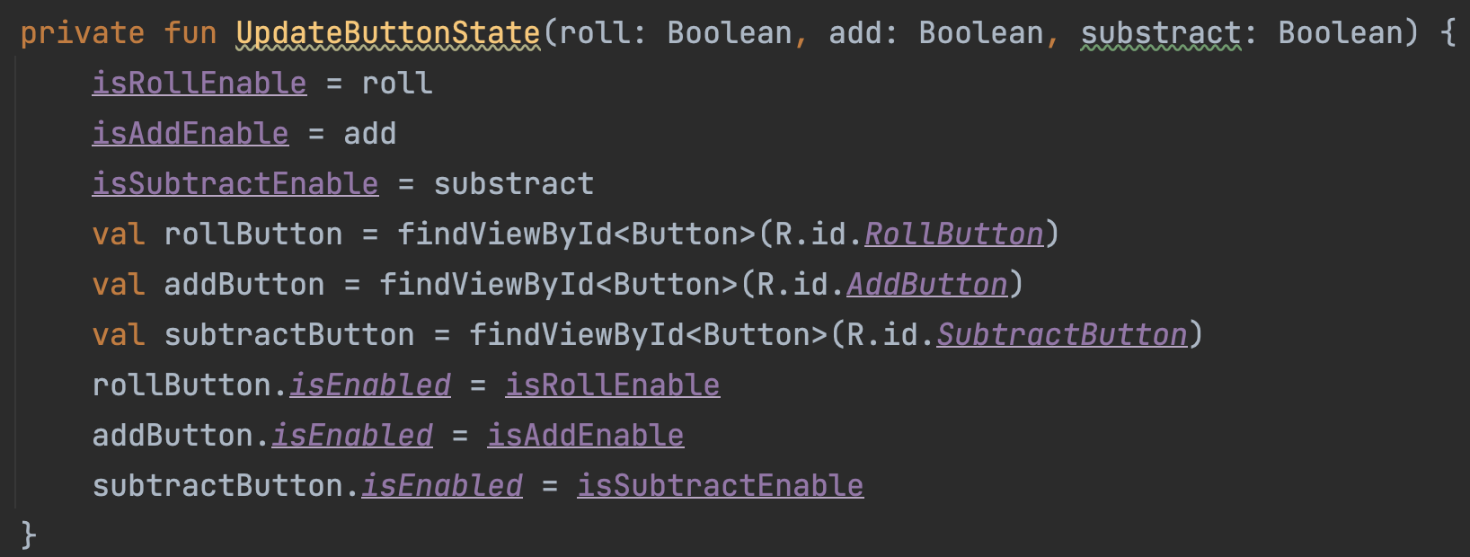
Figure 21 check the button state
Display the dice:

in order to display the dice, a function called DiceRolled will be created:

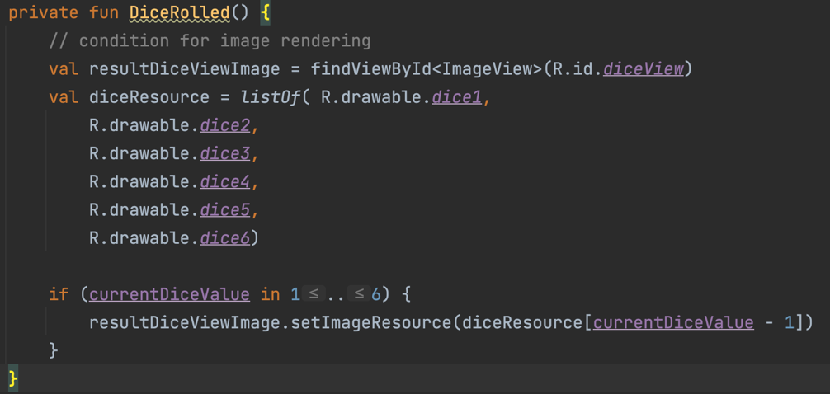
Figure 22 display the dice
the image to be displayed will depend on the current dice value. The image resource will be put in a list, when displaying the image, the current dice number has a range from 1 to 6 but in the list will be the range from 0 – 5 so it needs to be minus 1 to correctly display the image.

Gap 5: Save state when rotating
If we rotate the device, the program will onDestroy() and call onCreate() again. To
recover the values in the variable, we need to implement savedInstanceState. I will save the necessary variables which are the button state, the current dice value, and the total number (score):

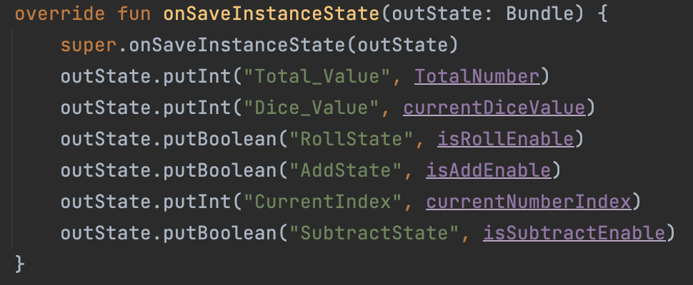
Figure 23 save instance state
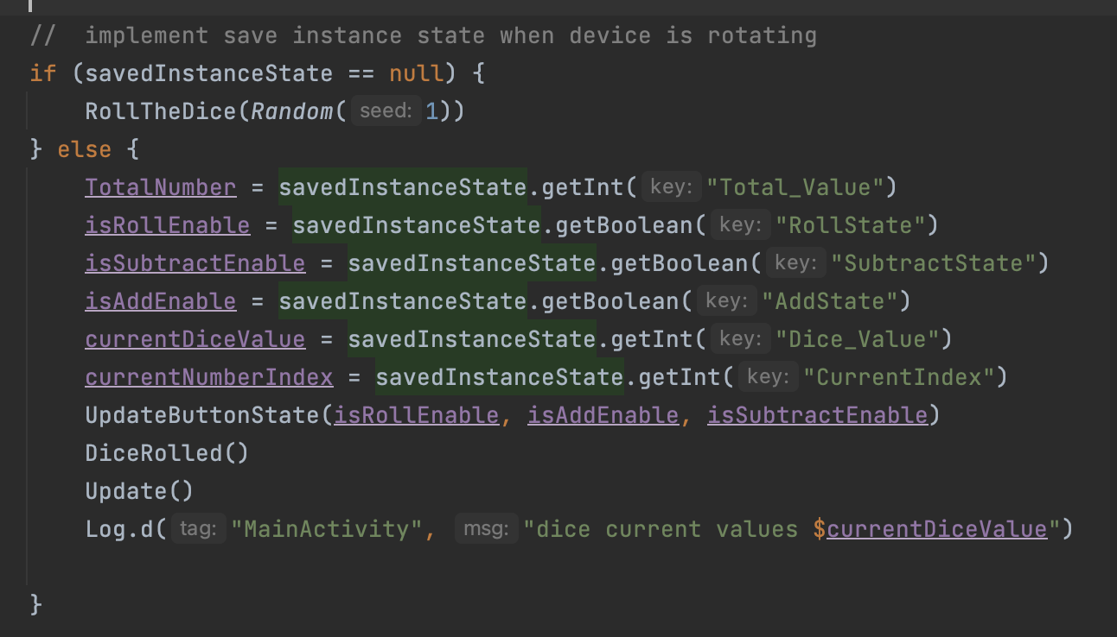
Figure 24 save instance state
Result:
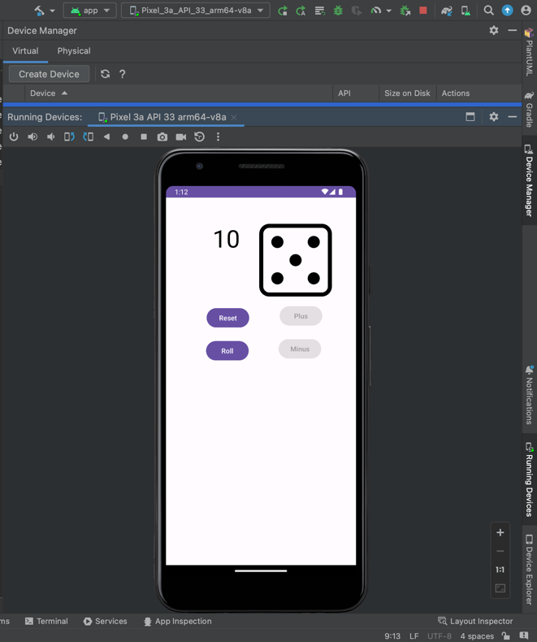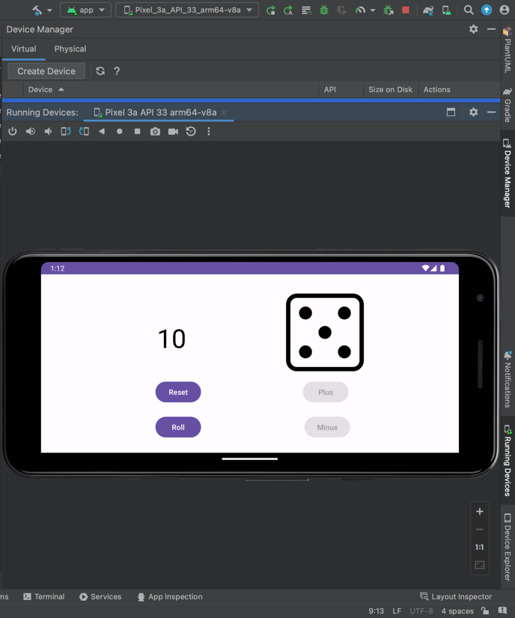
Figure 25 result for save instance state

Gap 6: Localizing the app
To make the app support different languages, I make the app adapt to 2 languages, the first one is Spanish, and the second one is Vietnamese. When changing the language in the system setting, the text in the app also being changed.

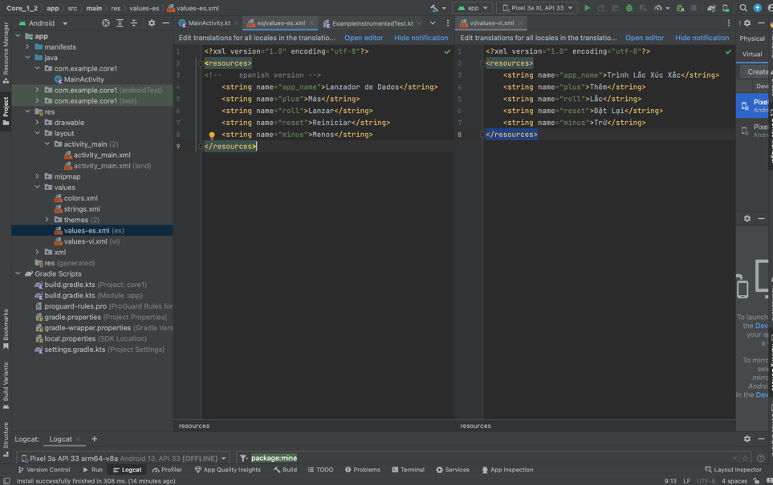
Figure 26 localizing
Result:

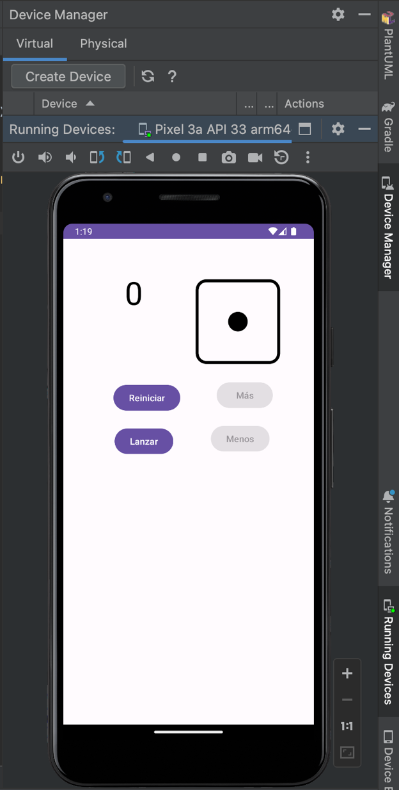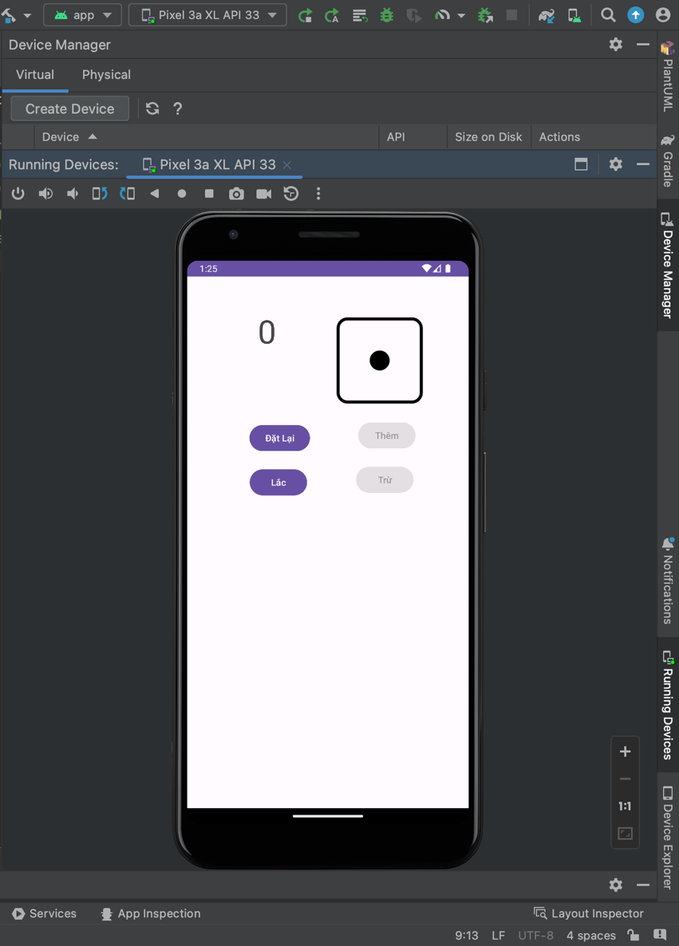
Figure 27 result

Gap 6: IDE Command:
We need to set up our emulator to run the app, We can select the one that already exists or we can create a new one in the device manager.
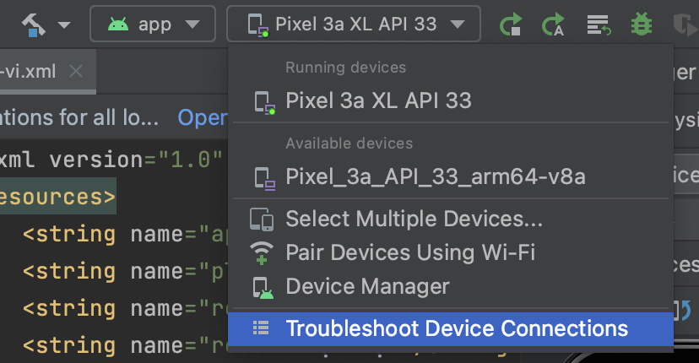
Figure 28 select emulator

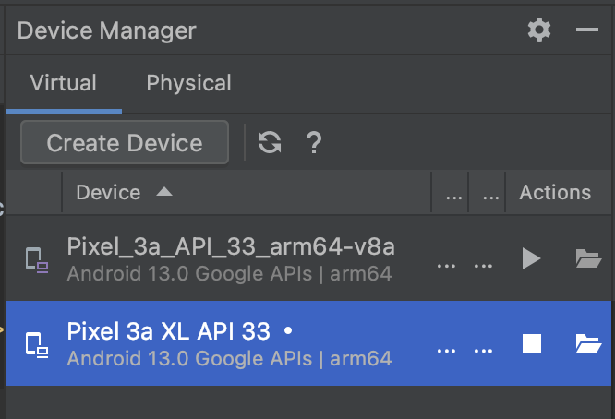
Figure 29 device manager

After creating the device, we can run our program by clicking the green play button, in this panel, we can also select debug the app by the bug icon:


Figure 30 control panel
We can debug the program using the breakpoint, the program will stop at the break point and we can see where the program goes by clicking the up or down button in the debug panel at the bottom.

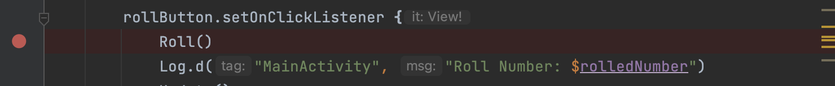
Figure 31 Example of breakpoint
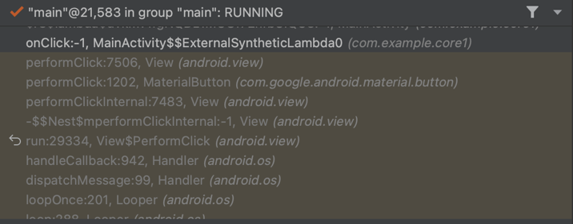
Figure 32 list of interaction

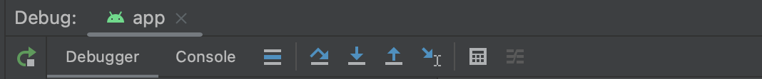
Figure 33 debug panel

Gap 7: Debug with log
When coding an app encountering errors or bugs is inevitable. Therefore, the log is a useful tool for debugging. In this app, some of the values for example list of random numbers is happen under the hood or when the score is over 20, the score will be frozen at 20 which not displayed in the interface so we can't access that. To view that variable values, I'm using log:

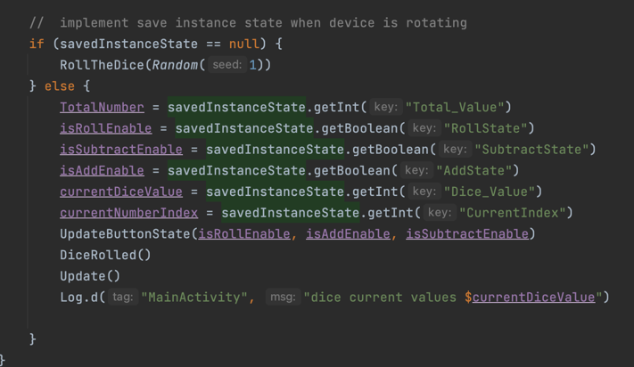
Figure 34 log example
For example, I log the current dice value, and at the time of coding the save instance state, I run into a bug in that the dice values are changed when rotating the device. After viewing that variable on the logcat, I can debug it. For another example, I want to see the list of random numbers when click the roll button, I log that list out (that list is being assigned to the rolled number var)
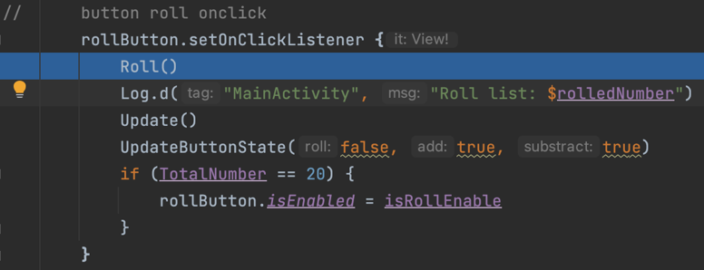
Figure 35 log example
Then I will be able to see the values of the variable that I log in the log cat (figure 36):

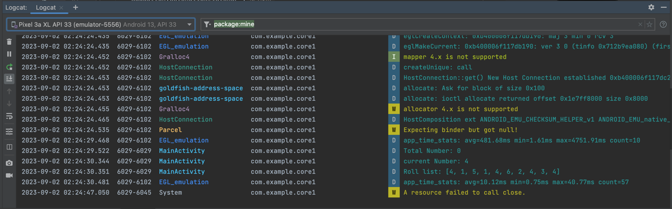
Figure 36 log cat

Gap 8: Testing the app
With the test file provided in GitHub, I take that down and test the program. The test file needs to put in the android test.
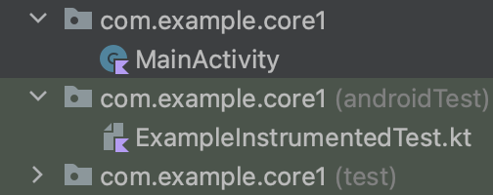
Figure 37 test file

After running the test, all six tests are passed without any issue:

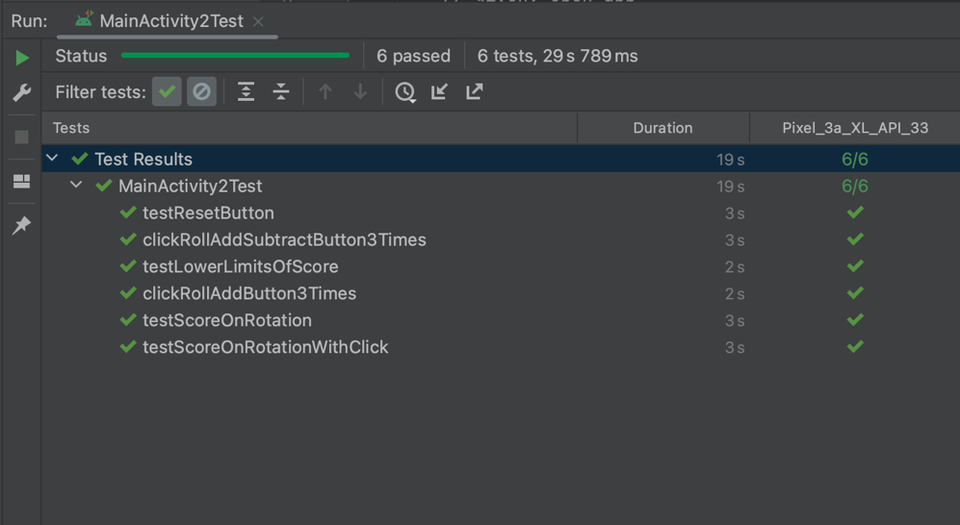
Figure 38 passed test

